**Distance Measures:**

We would like to be able to answer questions like, “How far is node A from node H?”, “are nodes far away or close to each other in this network?”.

**Distance:**

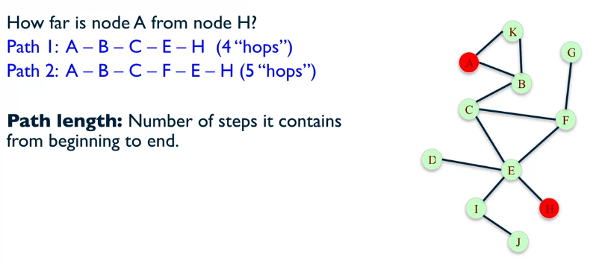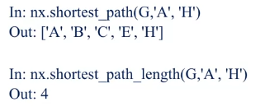

Where G in the above code is the graph.

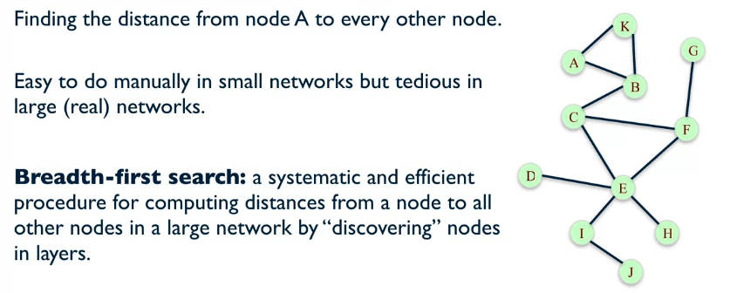

The breath-first search algorithm works by starting with the node chosen, in our case that is A. It then finds all the nodes connected to A, that is K and B, and these are labelled with distance 1. We then move onto looking at all unique nodes connected to those form the previous, e.g. looking at K we see that there are no new nodes so that branch ends. However, B has a new node C, so C becomes the next level of distance. From C we discover nodes F and E, and so on.

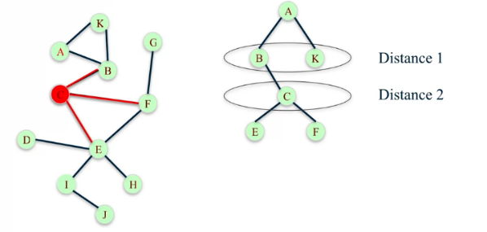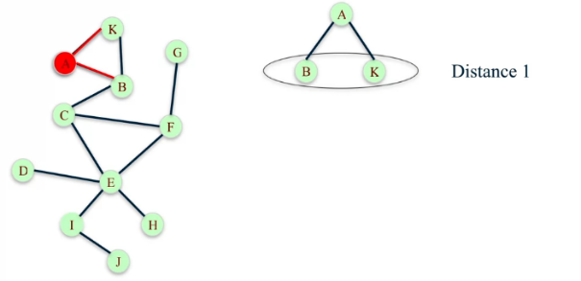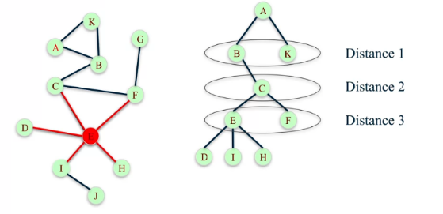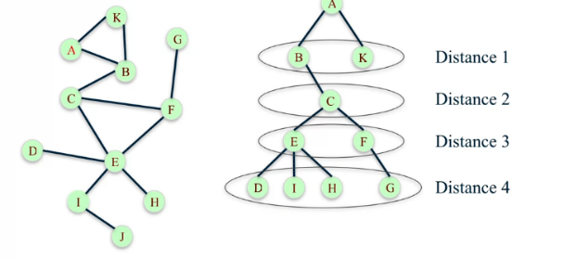

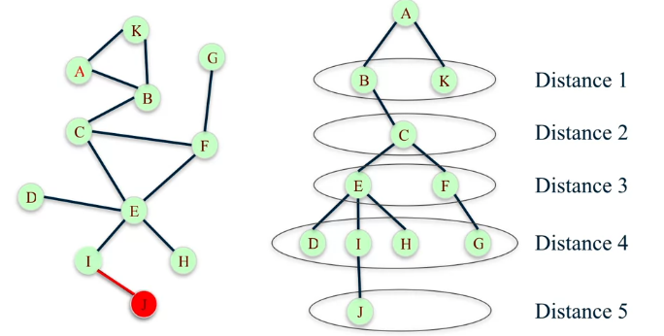

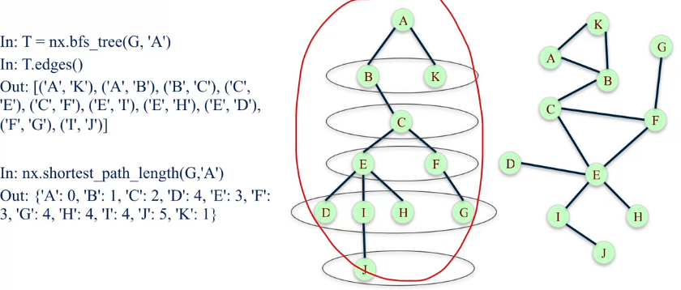We can use NetworkX to find the tree from this search and also all the edges of the tree. We can also return a dictionary of all the shortest path from one node to all the others:

This method is good for finding the distance between a node and other nodes, but what if we cant to know the a global distance measure of all the nodes in the network?

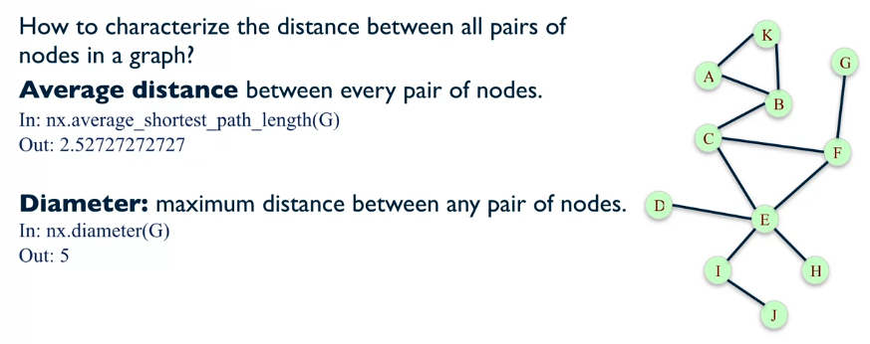

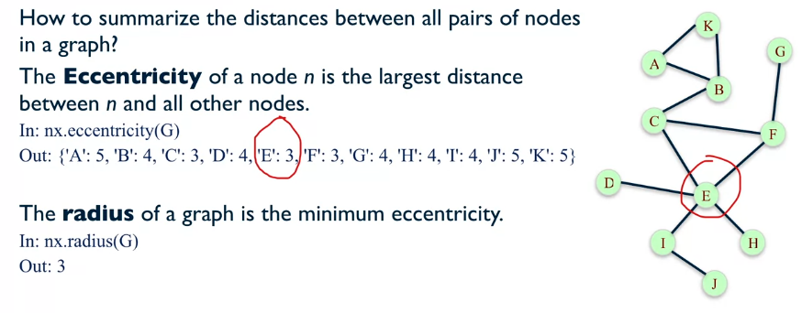

With these 4 different ways of comparing the distances of nodes in the network how do we summarize the distance between all pairs of nodes?

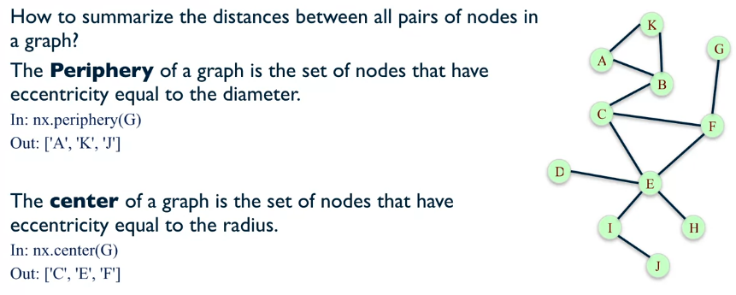

**Example:**

Background to network: shows a karate club with instructor (node 1) and assistant (node 34), they have an argument and the club splits up.

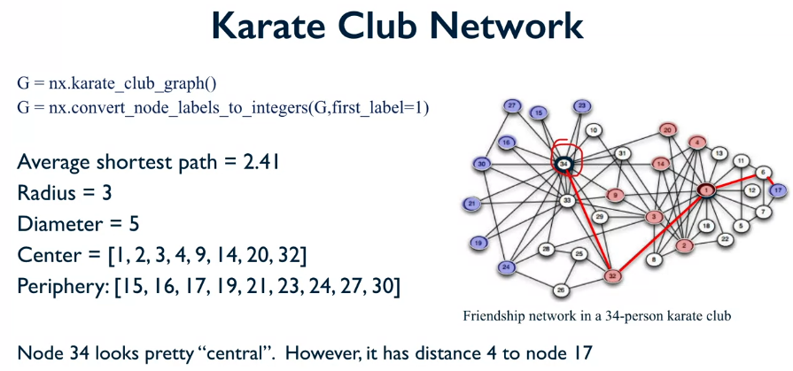

The nodes in blue are the periphery nodes, and the red nodes are the centre nodes. Node how 34, which is the assistant instructor, is not a central node… But it has so many connections? This is because the definition of the centre is very sensitive to path distance, and for 34 there is only 1 node that is distance greater than the radius away, making 34 a non-central point.

